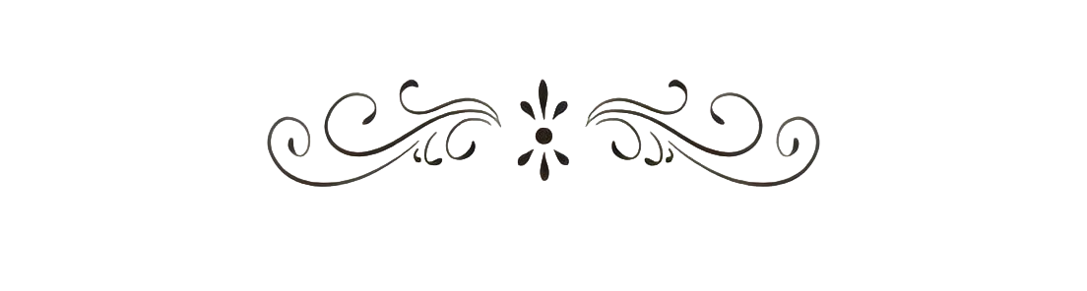





SRI AUROBINDO COLLEGE

**Dept.Of Commerce & Management**

**Commerce Association-‘Jnanagni’**

**Report on "BUSINESS RANGOLI” Event.**

**Convenor**- J. Manjunatha Rao

**Members-** Smt.Soujanya

Smt.Madhura

**Secretary**- Kavya Venkatesh (3rd B.Com ‘A’)

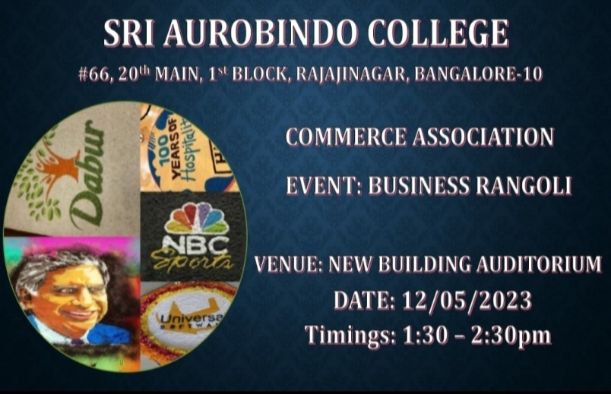

**DATE:**

**COMMERCE ASSOCIATION**

**Name of the Event: "Business Rangoli"**

**Objective of the Event: The objective of the event is to showcase the skills, talents and creativeness in protraiting the topic.**

**Outcome of the Event: Students by participating ,there was a great talents and skills showcased.**

**Target Audience-College Students.**

**Judges of the Event**

**1. Ms.Nazia Sultana Mam**

**2. Ms.Soujanya Mam**

**A Brief Report:**

**Commerce Association have organised an "Business Rangoli" event on 12th May 2023(Friday).**

**The circular was sent in advance to all B.com classes.**

**The Event was conducted in Auditorium (New Building) at 1.30 - 2.30pm**

**Topic of the Event:**

* **Design of the Product.**
* **Logos of the Company.**
* **Businessman/Personalities**
* **Symbol of the Company.**

**Rules of the Event:**

* **2 in a Team.**
* **1 Hour time limit.**
* **Use Rangoli with any combination of colours.**
* **Present in front of Judges.**

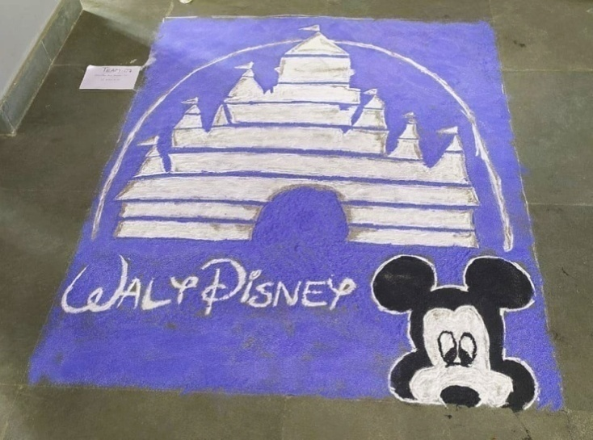**Totally 18 Teams were participated. Based on their drawing, colouring & presentation through their rangoli, Judges decided 3 teams as winners and 2 teams shares the consolation.**

**WINNERS OF BUSINESS RANGOLI EVENT**

|  |  |  |  |
| --- | --- | --- | --- |
| **SL NO** | **TEAM NAMES** | **CLASS & SECTION** | **PLACE** |
| **1** | **Mahalakshmi & Archana**  **(Amul Logo)** | **1st B.com** | **1st Place** |
| **2** | **Chandru & Goutham**  **(Starbucks Logo)** | **2nd B.com 'A'** | **2nd Place** |
| **3** | **Priya & Bhavani**  **(Social Medias Logo)** | **2nd B.com'A'** | **3rd Place** |
| **4** | **Kavya & Srilakshmi**  **(Foster Dairy logo)** | **2nd B.com'B'** | **Consolation** |
| **5** | **Poorvi & KavyaB.V**  **(Walt Disney Symbol)** | **3rd B.com 'B'** | **Consolation** |

**BUSINESS RANGOLI EVENT**

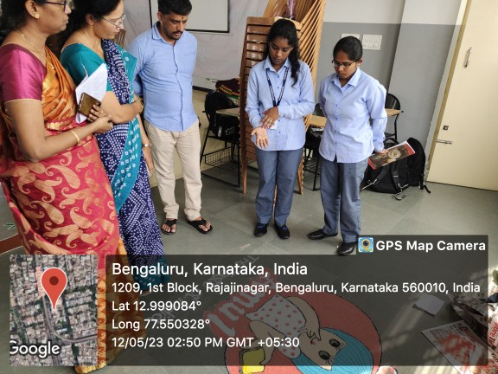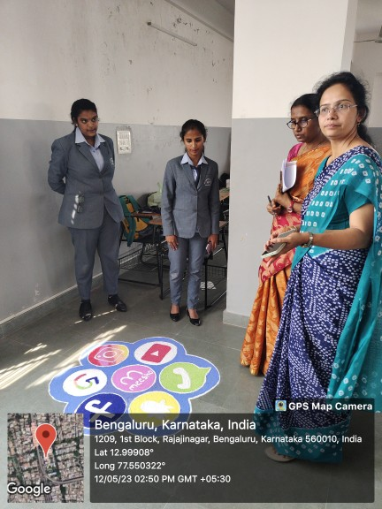

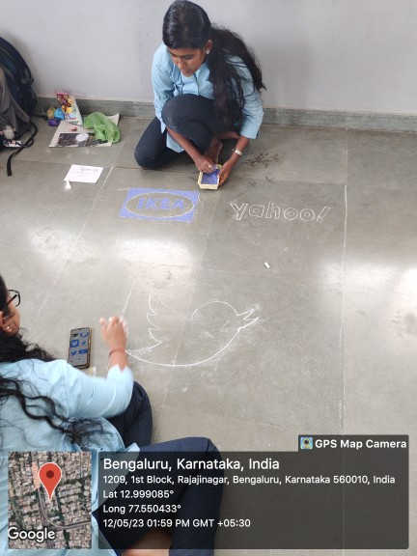

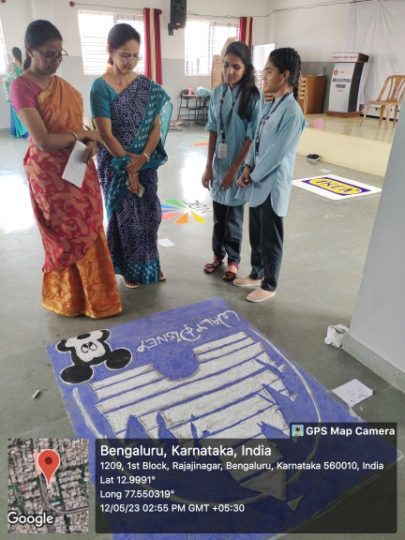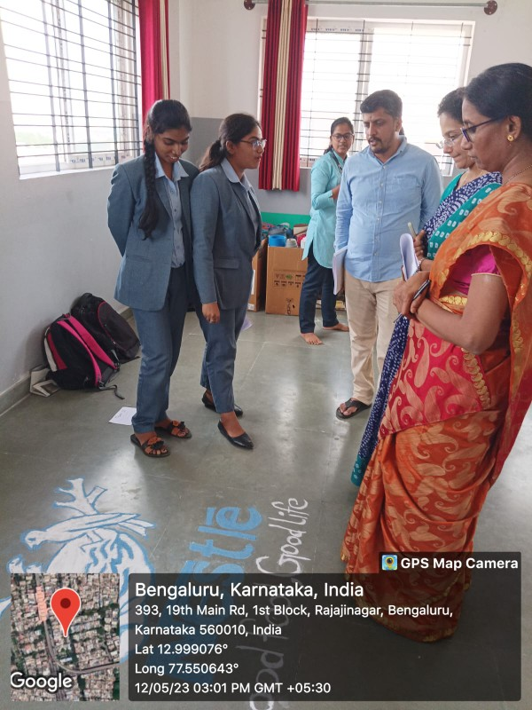

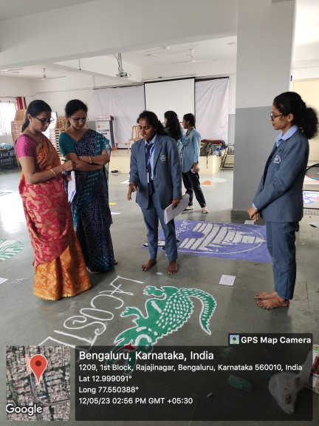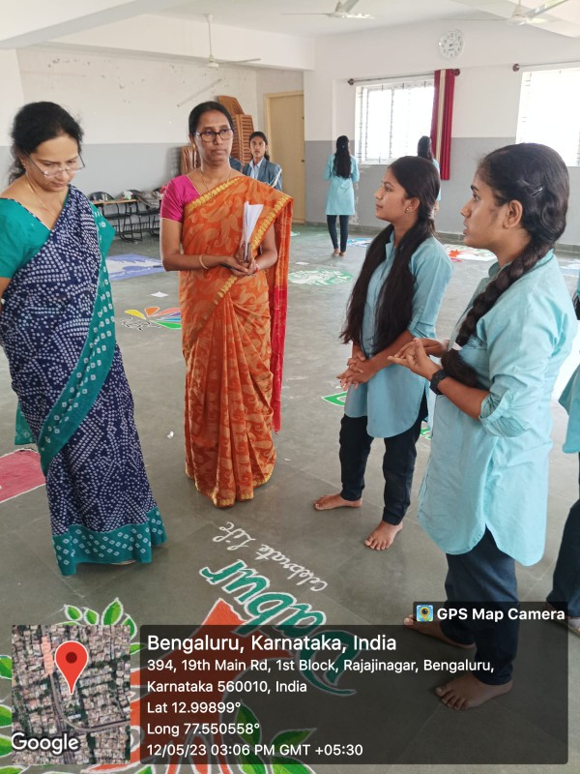

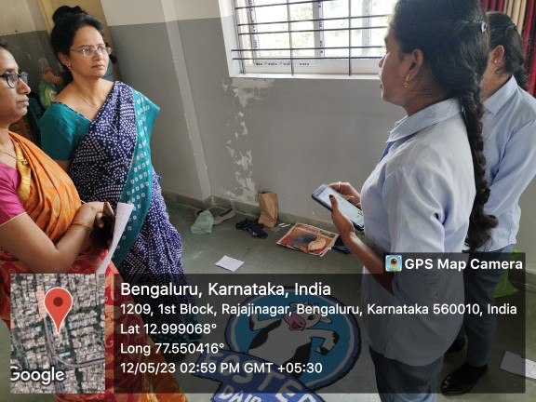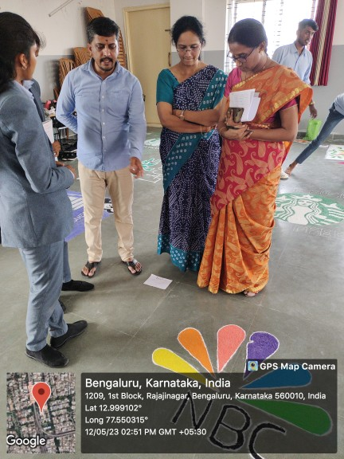

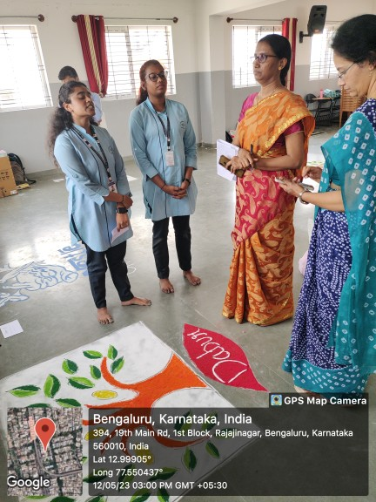

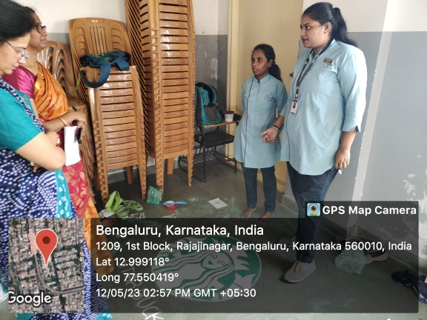

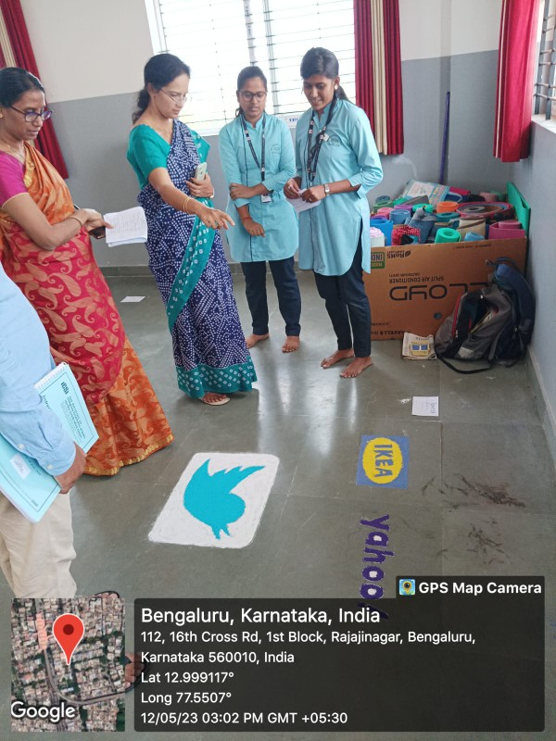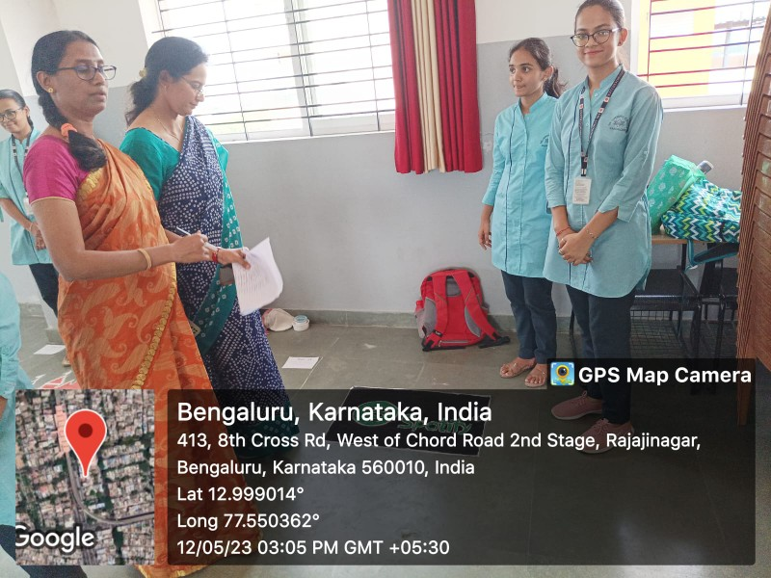

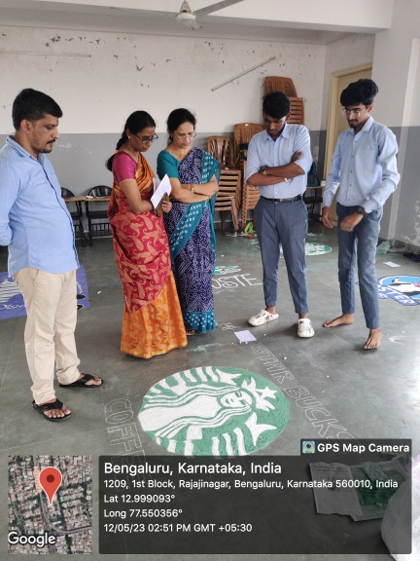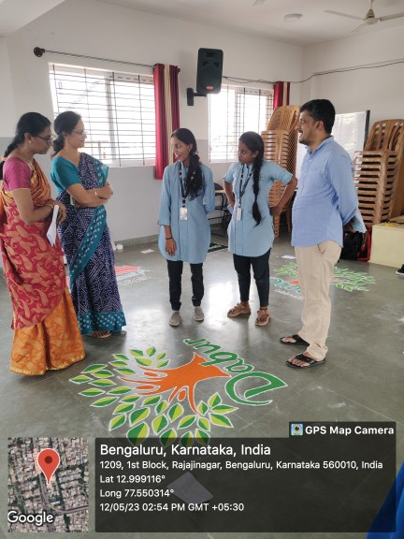

**PARTICIPANTS RANGOLIS**



